**Big Data Vs Traditional Approach**

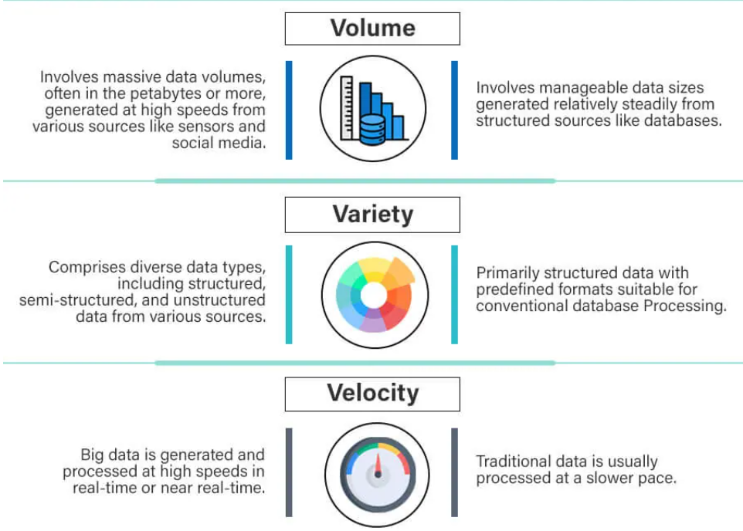

**Big Data Vs Traditional Approach**

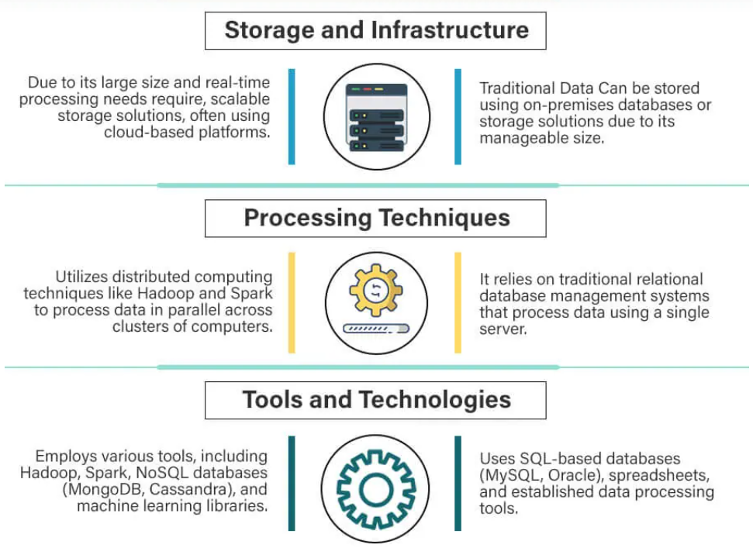

**Big Data Vs Traditional Approach**

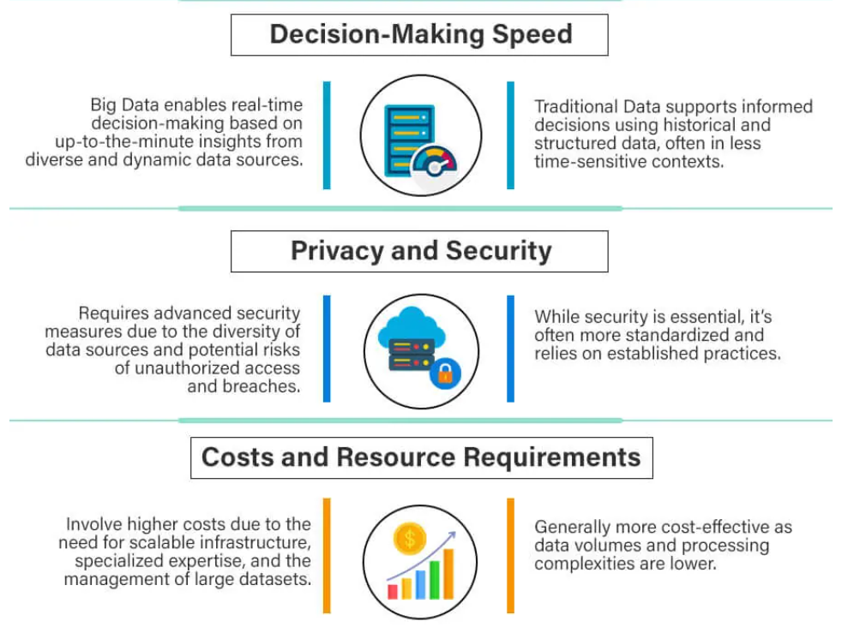

**Big Data Vs Traditional Approach**

